Lab 15-20
15.
#include <stdio.h>
#include <string.h>
#include <ctype.h>
void decrypt(char text[], int key)
{
int i;
char ch;
for(i = 0; text[i] != '\0'; i++)
{
ch = text[i];
if(isupper(ch))
printf("%c", ((ch - 'A' - key + 26) % 26) + 'A');
else if(islower(ch))
printf("%c", ((ch - 'a' - key + 26) % 26) + 'a');
else
printf("%c", ch);
}
}
int main()
{
char cipher[200];
int top, i;
printf("Enter Cipher Text: ");
fgets(cipher, sizeof(cipher), stdin);
printf("Enter number of possible plaintexts: ");
scanf("%d", &top);
if(top > 26)
top = 26;
printf("\nPossible Plaintexts:\n");
for(i = 0; i < top; i++)
{
printf("\nKey %d : ", i);
decrypt(cipher, i);
}
return 0;
}
16.
#include <stdio.h>
#include <ctype.h>
#include <string.h>
int main()
{
char cipher[500];
int freq[26] = {0};
int i;
printf("Enter Cipher Text: ");
fgets(cipher, sizeof(cipher), stdin);
for(i=0; cipher[i]!='\0'; i++)
{
if(isalpha(cipher[i]))
freq[toupper(cipher[i])-'A']++;
}
printf("\nLetter Frequencies:\n");
for(i=0;i<26;i++)
{
printf("%c : %d\n",'A'+i,freq[i]);
}
printf("\nPossible Mapping (Most Frequent -> E)\n");
int max=0,index=0;
for(i=0;i<26;i++)
{
if(freq[i]>max)
{
max=freq[i];
index=i;
}
}
printf("Highest Frequency Letter = %c\n",'A'+index);
printf("Likely Plaintext Letter = E\n");
printf("\n(Complete automatic monoalphabetic attack requires statistical analysis,\n");
printf("digram/trigram scoring and dictionary matching.)\n");
return 0;
}
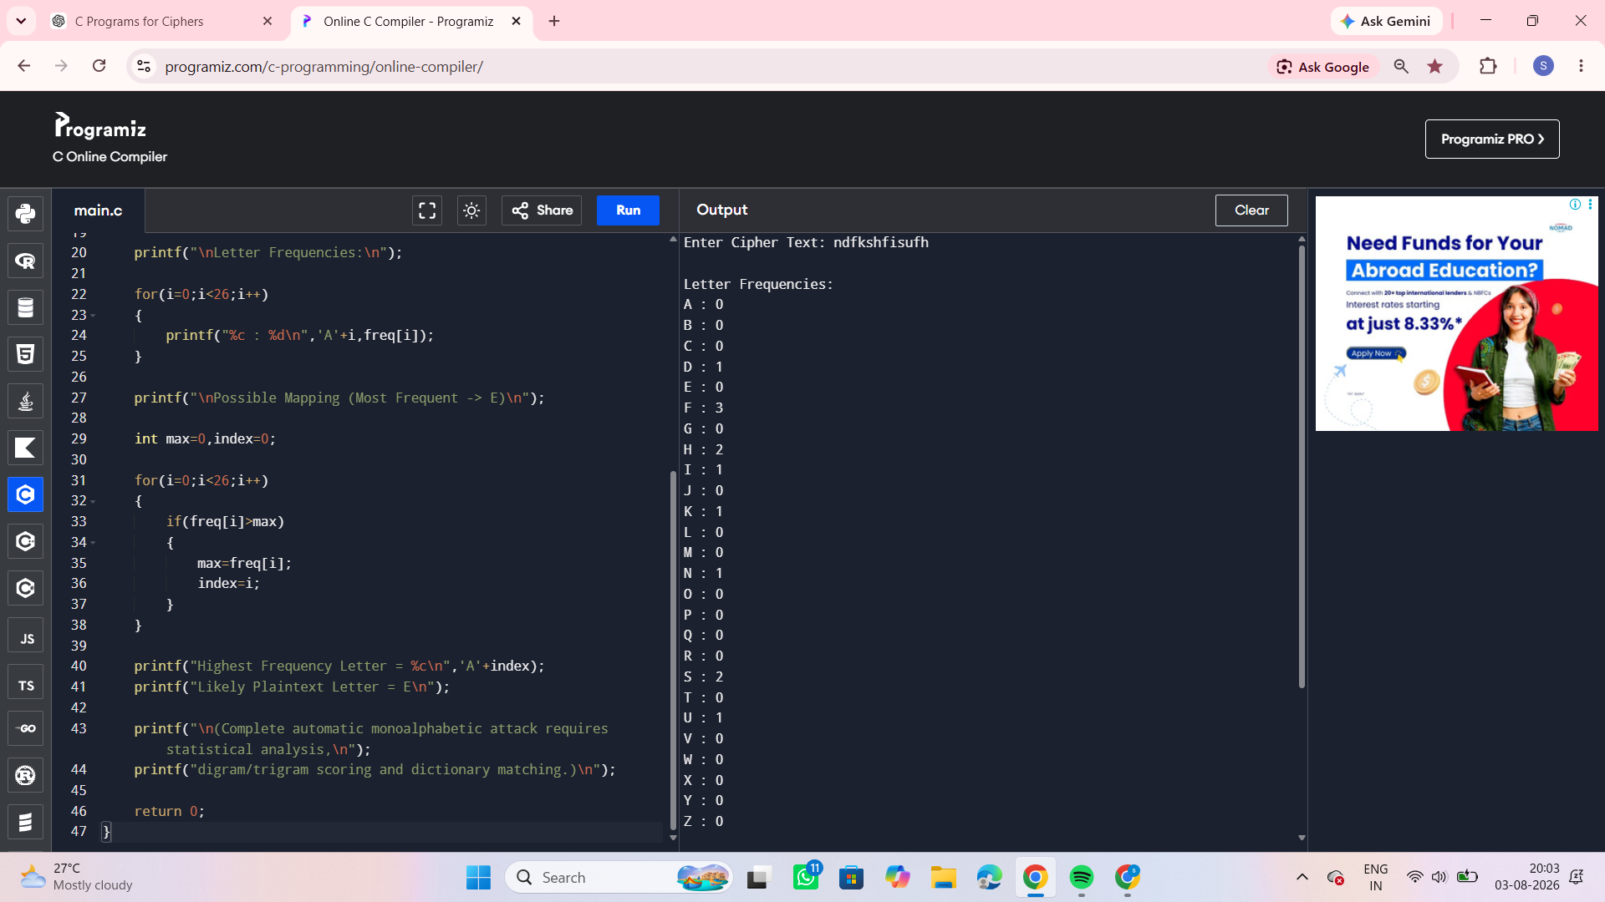

17.
#include <stdio.h>
int shiftSchedule[16] =
{
1,1,2,2,2,2,2,2,
1,2,2,2,2,2,2,1
};
int main()
{
int i;
printf("DES Encryption Shift Schedule\n");
for(i=0;i<16;i++)
{
printf("Round %2d Shift = %d\n",
i+1,
shiftSchedule[i]);
}
printf("\nDES Decryption Key Order\n");
for(i=15;i>=0;i--)
{
printf("Round %2d uses Encryption Key K%d\n",
16-i,
i+1);
}
return 0;
}
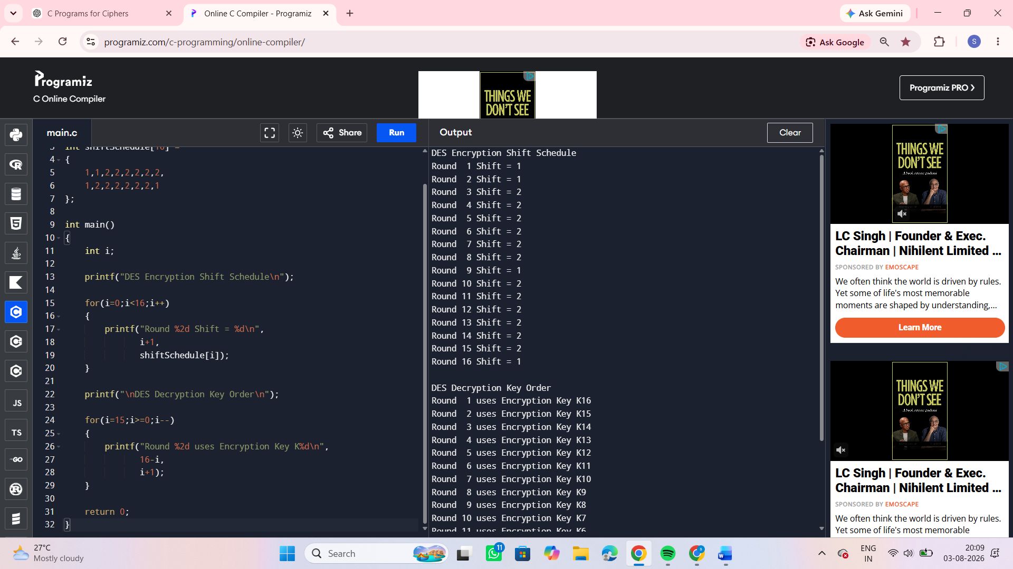
18.
#include <stdio.h>
int main()
{
int i;
printf("DES Subkey Generation\n\n");
printf("Left Half (28 bits):\n");
for(i=1;i<=28;i++)
printf("%2d ",i);
printf("\n\nRight Half (28 bits):\n");
for(i=29;i<=56;i++)
printf("%2d ",i);
printf("\n\n");
printf("Observation:\n");
printf("First 24 bits of every subkey come only from Left Half.\n");
printf("Second 24 bits come only from Right Half.\n");
printf("Both halves remain disjoint throughout key scheduling.\n");
return 0;
}
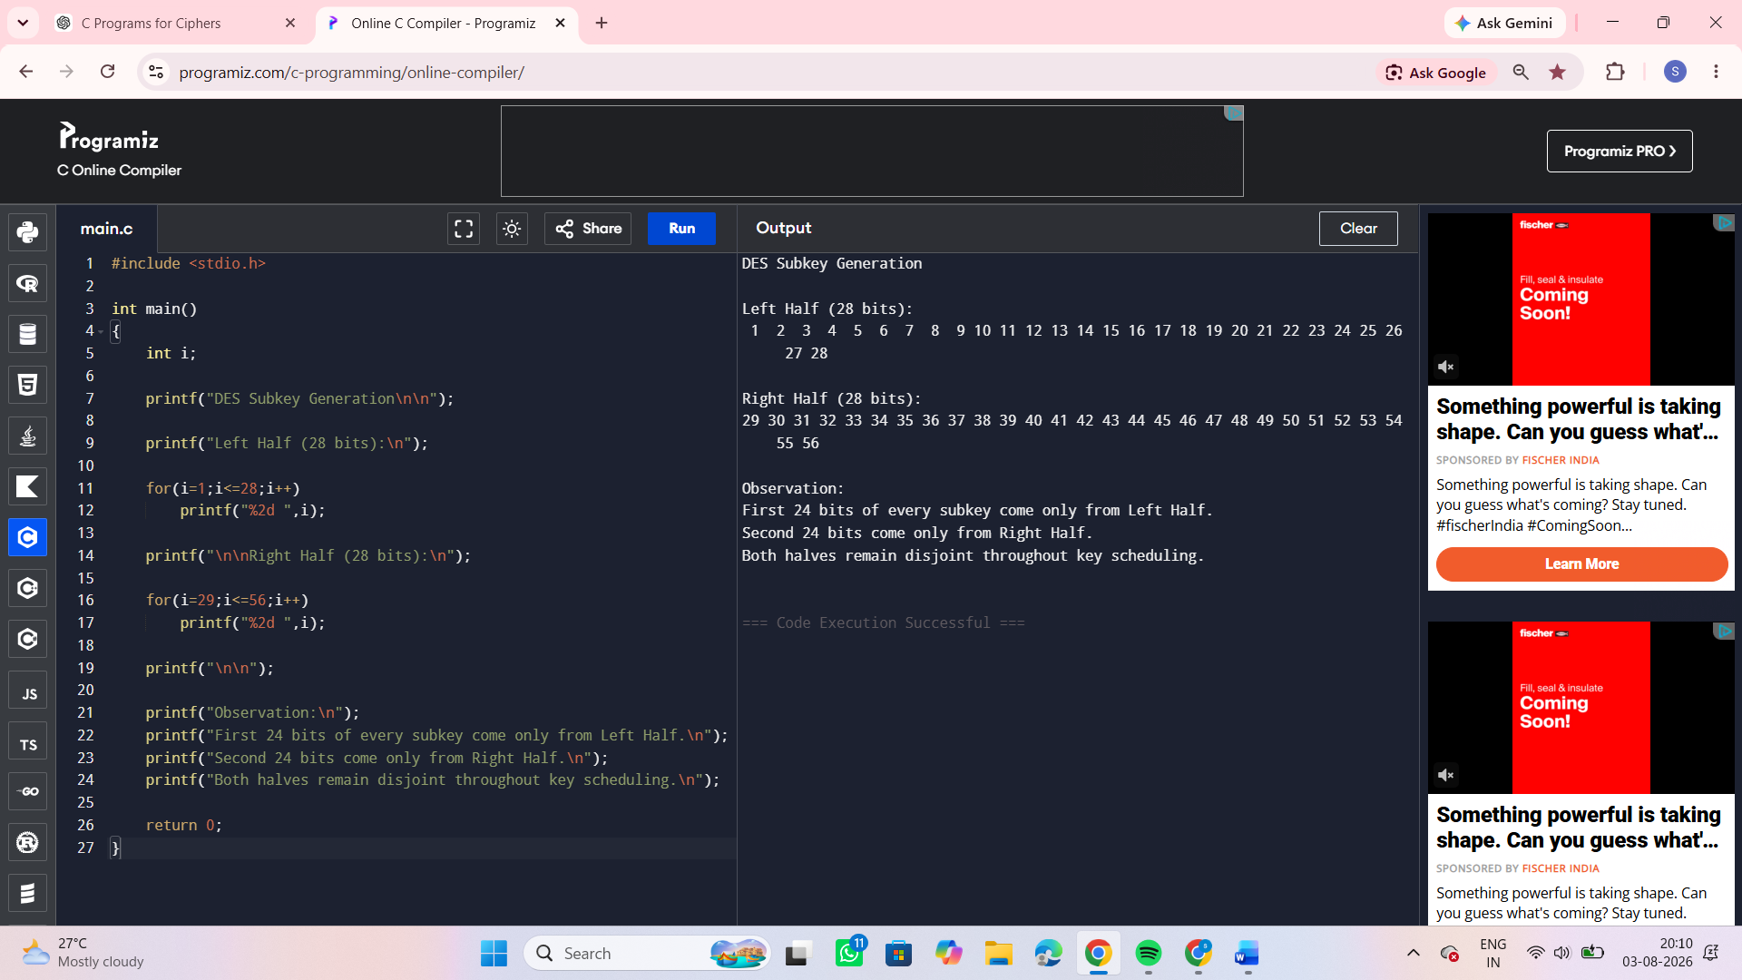
19.
#include <stdio.h>
int main()
{
int plaintext[4];
int key = 25;
int iv;
int i;
printf("Enter 4 plaintext blocks:\n");
for(i=0;i<4;i++)
scanf("%d",&plaintext[i]);
printf("Enter IV: ");
scanf("%d",&iv);
printf("\nCipher Blocks:\n");
int previous = iv;
int cipher;
for(i=0;i<4;i++)
{
cipher = (plaintext[i] ^ previous) ^ key;
printf("C%d = %d\n",i+1,cipher);
previous = cipher;
}
printf("\nSecurity Choice : 3DES\n");
printf("Performance Choice : DES (Faster but weaker)\n");
return 0;
}
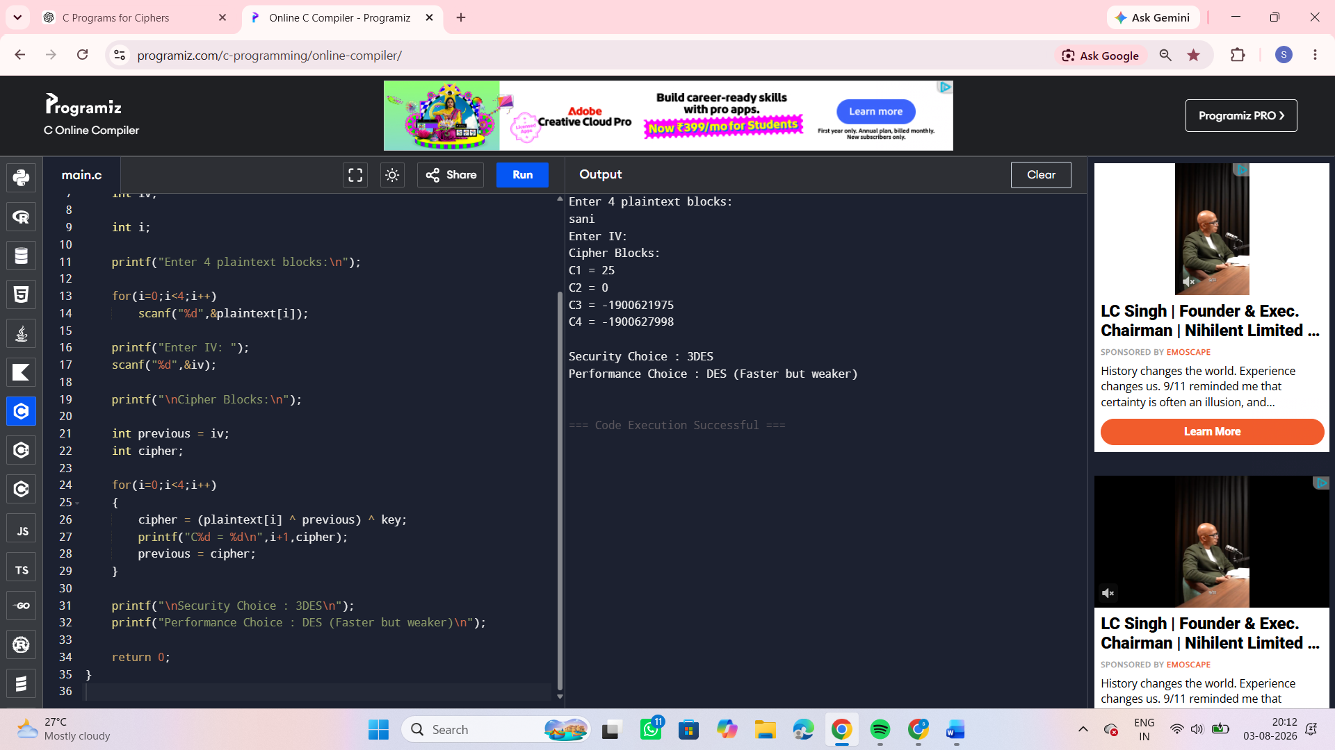
20.
#include <stdio.h>
int main()
{
printf("ECB Error Propagation\n");
printf("----------------------\n");
printf("Ciphertext Error in C1 affects only P1.\n\n");
printf("CBC Error Propagation\n");
printf("----------------------\n");
printf("Ciphertext Error in C1 affects:\n");
printf("P1 completely\n");
printf("P2 partially (one bit)\n");
printf("No further blocks are affected.\n\n");
printf("Bit Error in Plaintext P1\n");
printf("-------------------------\n");
printf("ECB : Only C1 changes.\n");
printf("CBC : C1 changes, which also changes C2 during decryption.\n");
return 0;
}
